**Work Breakdown Structure (WBS)**

**D7 Auto Service Center web-app**

**D7 auto service center**

**Street Address**

**City, State Zip Code**

**Date**

# Introduction

The Work Breakdown Structure presented here represents all the work required to complete this project. It will be the initial version of the web-app and it shall go under version 1. This version will undergo the PBL (Project Based Learning) phases from planning to deployment. It is hereby outlined with the help of this project management tool that will aim to provide better division of work during each respective phase. The project has divided the work accordingly per sprint to have them assigned and accomplished by the Elite Four team.

# Outline View

1. **D7 Auto Service Center Web-app**
   1. **Planning**
      1. Planning Phase Preparations
      2. Sprint I Works
      3. Sprint I Presentation
      4. Sprint II Works
      5. Planning Phase Presentation
   2. **System Analysis & Design**
      1. System Analysis & Design Phase Preparations
      2. Sprint III Works
      3. Sprint III Presentation
      4. Sprint IV Works
      5. System Analysis & Design Presentation (Sprint V)
   3. **Development** 
      1. Project Development Phase Preparation
      2. Release Plan 1
      3. Sprint VI Works
      4. Release Plan 2
      5. Sprint VII Presentation
      6. Release Plan 3
      7. Sprint VIII Works
      8. Development Phase Presentation
   4. **Deployment** 
      1. Deployment Phase Preparation
      2. Sprint IX Works
      3. Sprint X Works
      4. Sprint X Continuation
      5. Sprint XI Works
      6. Deployment Phase Presentation (Sprint XII)
   5. **Closeout** 
      1. Project Turn Over
      2. Documentations
      3. Project Demonstration

# Hierarchical Structure

|  |  |  |
| --- | --- | --- |
| Level | WBS Code | Element Name |
| 1 | 1 | D7 Auto Service Center Web-App |
| **2** | **1.1** | **Planning** |
| 3 | 1.1.1 | Planning Phase Preparations |
| 3 | 1.1.2 | Sprint I Works |
| 3 | 1.1.3 | Sprint I Presentation |
| 3 | 1.1.4 | Sprint II Works |
| 3 | 1.1.5 | Planning Phase Presentation |
| **2** | **1.2** | **System Analysis & Design** |
| 3 | 1.2.1 | System Analysis & Design Phase Preparations |
| 3 | 1.2.2 | Sprint III Works |
| 3 | 1.2.3 | Sprint III Presentation |
| 3 | 1.2.4 | Sprint IV Works |
| 3 | 1.2.5 | System Analysis & Design Presentation (Sprint V) |
| **2** | **1.3** | **Development** |
| 3 | 1.3.1 | Project Development Phase Preparation |
| 3 | 1.3.2 | Release Plan 1 |
| 3 | 1.3.3 | Sprint VI Works |
| 3 | 1.3.4 | Release Plan 2 |
| 3 | 1.3.5 | Sprint VII Presentation |
| 3 | 1.3.6 | Release Plan 3 |
| 3 | 1.3.7 | Sprint VIII Works |
| 3 | 1.3.8 | Development Phase Presentation |
| **2** | **1.4** | **Deployment** |
| 3 | 1.4.1 | Deployment Phase Preparation |
| 3 | 1.4.2 | Sprint IX Works |
| 3 | 1.4.3 | Sprint X Works |
| 3 | 1.4.4 | Sprint X Continuation |
| 3 | 1.4.5 | Sprint XI Works |
| 3 | 1.4.6 | Deployment Phase Presentation (Sprint XII) |
| **2** | **1.5** | **Close Out** |
| 3 | 1.5.1 | Project Turn Over |
| 3 | 1.5.2 | Documentations |
| 3 | 1.5.3 | Project Demonstration |

# Tabular View

|  |  |  |
| --- | --- | --- |
| Level 1 | Level 2 | Level 3 |
| 1 D7 Auto Service Center Web-App | * 1. Planning | * + 1. Planning Phase Preparations     2. Sprint I Works     3. Sprint I Presentation     4. Sprint II Works     5. Planning Phase Presentation |
| 1.2 System Analysis & Design | * + 1. System Analysis & Design Phase Preparations     2. Sprint III Works     3. Sprint III Presentation     4. Sprint IV Works     5. System Analysis & Design Phase Presentation (Sprint V) |
| * 1. Development | * + 1. Project Development Phase Preparation     2. Release Plan 1     3. Sprint VI Works     4. Release Plan 2     5. Sprint VII Presentation     6. Release Plan 3     7. Sprint VIII Works     8. Development Phase Presentation |
| 1.4 Deployment | 1.4.1 Deployment Phase Preparation  1.4.2 Sprint IX Works  1.4.3 Sprint X Works  1.4.4 Sprint X Continuation  1.4.5 Sprint XI Works  1.4.6 Sprint XII Creation and Presentation |
|  | 1.5 Close Out | 1.5.1 Project Turn Over  1.5.2 Documentations  1.5.3 Project Demonstration |

# Tree Structure View

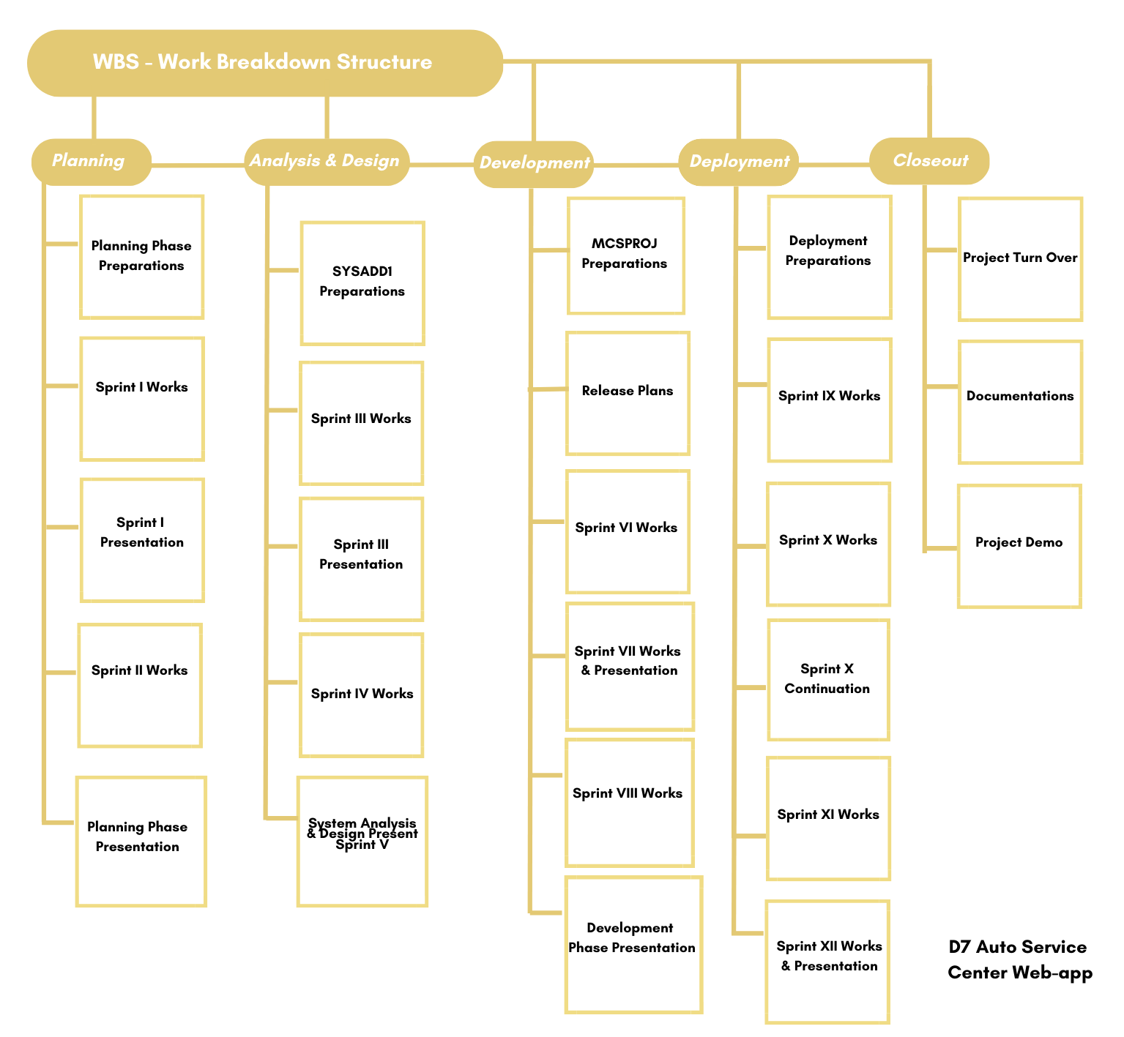

# WBS Dictionary

| Level | WBS Code | Element Name | Definition | Estimated Duration |
| --- | --- | --- | --- | --- |
| 1 | 1 | D7 Auto Service Center Web-App | A web-application as an additional platform for D7 | **331 Days** |
| **2** | **1.1** | **Planning** | **Comprised of planning essentials for the project** | **83 Days** |
| 3 | 1.1.1 | Planning Phase Preparations | Project Adviser and Client search | 20 Days |
| 3 | 1.1.2 | Sprint I Works | Brainstorming and signing | 12 Days |
| 3 | 1.1.3 | Sprint I Presentation | Presentation of possible ideas | 9 Days |
| 3 | 1.1.4 | Sprint II Works | Continuation of planning for chosen project | 23 Days |
| 3 | 1.1.5 | Planning Phase Presentation | Finalization of plans and heads up for system analysis and design | 19 Days |
| **2** | **1.2** | **System Analysis & Design** | **Comprised of System Analysis and Designing of chosen project** | **89 Days** |
| 3 | 1.2.1 | System Analysis & Design Phase Preparations | Project Adviser and Consultant search | 10 Days |
| 3 | 1.2.2 | Sprint III Works | Analysis of context and data flow of system | 29 Days |
| 3 | 1.2.3 | Sprint III Presentation | Presentation of Works from Sprints | 10 Days |
| 3 | 1.2.4 | Sprint IV Works | Documentation proper of project and more analysis of system | 30 Days |
| 3 | 1.2.5 | System Analysis & Design Presentation (Sprint V) | System structure, deployment, activities and deployment diagrams & Finalization of System Analysis and Design | 10 Days |
| **2** | **1.3** | **Development** | **Comprised of Development of system features and web-app** | **86 Days** |
| 3 | 1.3.1 | Project Development Phase Preparation | Project Adviser and Consultant search | 5 Days |
| 3 | 1.3.2 | Release Plan 1 | Initial creation of features for the web-app | 38 Days |
| 3 | 1.3.3 | Sprint VI Works | Documentation and finalization of release plan 1 | 30 Days |
| 3 | 1.3.4 | Release Plan 2 | Continuation of creation of project features | 33 Days |
| 3 | 1.3.5 | Sprint VII Presentation | Presentation of development progress | 5 Days |
|  | 1.3.6 | Release Plan 3 | Continuation of final features creation | 13 Days |
| 3 | 1.3.7 | Sprint VII Works | Finalization of documentation for development and features of web-app | 30 Days |
| 3 | 1.3.8 | Development Phase Presentation (Sprint VIII) | Completion and presentation of development phase of web-app | 16 Days |
| **2** | **1.4** | **Deployment** | **Comprised of proper documentation, and project managing of web-app** | **70 Days** |
| 3 | 1.4.1 | Deployment Phase Preparation | Project Adviser and Consultant search | 5 Days |
| 3 | 1.4.2 | Sprint IX Works | Documentation of work division and work management | 20 Days |
| 3 | 1.4.3 | Sprint X Works | Continuation of documentation for web-app management and budgeting | 15 Days |
| 3 | 1.4.4 | Sprint X Continuation | Continuation of documentation and deployment preparation | 5 Days |
| 3 | 1.4.5 | Sprint XI Works | Finalization of Documentations for PROJMAN and Client Meetings | 20 Days |
| 3 | 1.4.6 | Deployment Phase Presentation (Sprint XII) | Presentation for PROJMAN and Deployment of Web-App | 5 Days |
| **2** | **1.5** | **Close Out** | **Comprised of project turnover and closeout to client** | 3 Days |
| 3 | 1.5.1 | Project Turn Over | Formal event of turnover of project to D7 Auto Service Center | 1 Day |
| 3 | 1.5.2 | Documentations | Release of copies of technical documentation to D7 Auto Service Center | 1 Day |
| 3 | 1.5.3 | Project Demonstration | Demonstration of project tutorial to project sponsor and D7 Auto Service Center Management | 1 Day |

# Glossary of Terms

|  |  |
| --- | --- |
| Terms | Definition |
| Level of Effort: | Level of Effort (LOE) refers to the amount of work needed to accomplish a task. |
| WBS Code: | A unique identifier assigned to each element in a Work Breakdown Structure to indicate its position within the hierarchical structure of the WBS. |
| Work Package: | A Work Package is a unit of work or a deliverable that belongs to the lowest level of a specific branch in the Work Breakdown Structure (WBS). |
| WBS Component: | A WBS component is a part of the Work Breakdown Structure that can be located at any level, and it can either be a Work Package or a WBS Element since there are no limitations on what a WBS Component can be. |
| WBS Element: | A WBS Element is a fundamental unit of the Work Breakdown Structure that has distinct qualities and can be situated at any tier of the structure. It may consist of tasks that require completion, in addition to other WBS Elements or Work Packages that are nested within it. |
| WBS Estimated Duration: | The Estimated Duration in WBS refers to the amount of time that is expected to be required for completing a particular task or activity. |

This free WBS Template is brought to you by [www.ProjectManagementDocs.com](http://www.ProjectManagementDocs.com)

# 